shylajaiyer@cloudshell:~ (glowing-sanctum-482200-f5)$ gcloud config set project glowing-sanctum-482200-f5
Updated property [core/project].
shylajaiyer@cloudshell:~ (glowing-sanctum-482200-f5)$ gcloud pubsub topics create demo-topic
Created topic [projects/glowing-sanctum-482200-f5/topics/demo-topic].
shylajaiyer@cloudshell:~ (glowing-sanctum-482200-f5)$ gcloud pubsub subscriptions create demo-sub --topic = demo-topic --ack-deadline=20s
ERROR: (gcloud.pubsub.subscriptions.create) argument --ack-deadline: invalid int value: '20s'
Usage: gcloud pubsub subscriptions create SUBSCRIPTION [SUBSCRIPTION ...] (--topic=TOPIC : --topic-project=TOPIC_PROJECT) [optional flags]
optional flags may be --ack-deadline | --bigquery-service-account-email |
--bigquery-table | --cloud-storage-bucket |
--cloud-storage-file-datetime-format |
--cloud-storage-file-prefix |
--cloud-storage-file-suffix |
--cloud-storage-max-bytes |
--cloud-storage-max-duration |
--cloud-storage-max-messages |
--cloud-storage-output-format |
--cloud-storage-service-account-email |
--cloud-storage-use-topic-schema |
--cloud-storage-write-metadata | --dead-letter-topic |
--dead-letter-topic-project | --drop-unknown-fields |
--enable-exactly-once-delivery |
--enable-message-ordering | --expiration-period |
--help | --labels | --max-delivery-attempts |
--max-retry-delay | --message-filter |
--message-retention-duration |
--message-transforms-file | --min-retry-delay |
--push-auth-service-account |
--push-auth-token-audience | --push-endpoint |
--push-no-wrapper | --push-no-wrapper-write-metadata |
--retain-acked-messages | --tags | --topic-project |
--use-table-schema | --use-topic-schema |
--write-metadata

For detailed information on this command and its flags, run:
gcloud pubsub subscriptions create --help
shylajaiyer@cloudshell:~ (glowing-sanctum-482200-f5)$ gcloud pubsub subscriptions create demo-sub --topic = demo-topic --ack-deadline=20
ERROR: (gcloud.pubsub.subscriptions.create) unrecognized arguments: demo-topic

To search the help text of gcloud commands, run:
gcloud help -- SEARCH_TERMS
shylajaiyer@cloudshell:~ (glowing-sanctum-482200-f5)$ gcloud pubsub subscriptions create demo-sub --topic=demo-topic --ack-deadline=20
Created subscription [projects/glowing-sanctum-482200-f5/subscriptions/demo-sub].
shylajaiyer@cloudshell:~ (glowing-sanctum-482200-f5)$ gcloud pubsub publish topic demo-topic --message="Test1"
ERROR: (gcloud.pubsub) Invalid choice: 'publish'.
Maybe you meant:
gcloud pubsub
gcloud topic

To search the help text of gcloud commands, run:
gcloud help -- SEARCH_TERMS
shylajaiyer@cloudshell:~ (glowing-sanctum-482200-f5)$ gcloud pubsub topics publish demo-topic --message="Test1"
messageIds:
- '17559445808516775'
shylajaiyer@cloudshell:~ (glowing-sanctum-482200-f5)$ gcloud pubsub topics publish demo-topic --message="Test2"
messageIds:
- '17552633070085256'
shylajaiyer@cloudshell:~ (glowing-sanctum-482200-f5)$ gcloud pubsub topics publish demo-topic --message="Test3"
messageIds:
- '17560335608089027'
shylajaiyer@cloudshell:~ (glowing-sanctum-482200-f5)$ gcloud pubsub subscriptions pull demo-sub --limit=5 --auto-ack
DATA: Test1
MESSAGE_ID: 17559445808516775
ORDERING_KEY:
ATTRIBUTES:
DELIVERY_ATTEMPT:
ACK_STATUS: SUCCESS

DATA: Test3
MESSAGE_ID: 17560335608089027
ORDERING_KEY:
ATTRIBUTES:
DELIVERY_ATTEMPT:
ACK_STATUS: SUCCESS

DATA: Test2
MESSAGE_ID: 17552633070085256
ORDERING_KEY:
ATTRIBUTES:
DELIVERY_ATTEMPT:
ACK_STATUS: SUCCESS
shylajaiyer@cloudshell:~ (glowing-sanctum-482200-f5)$

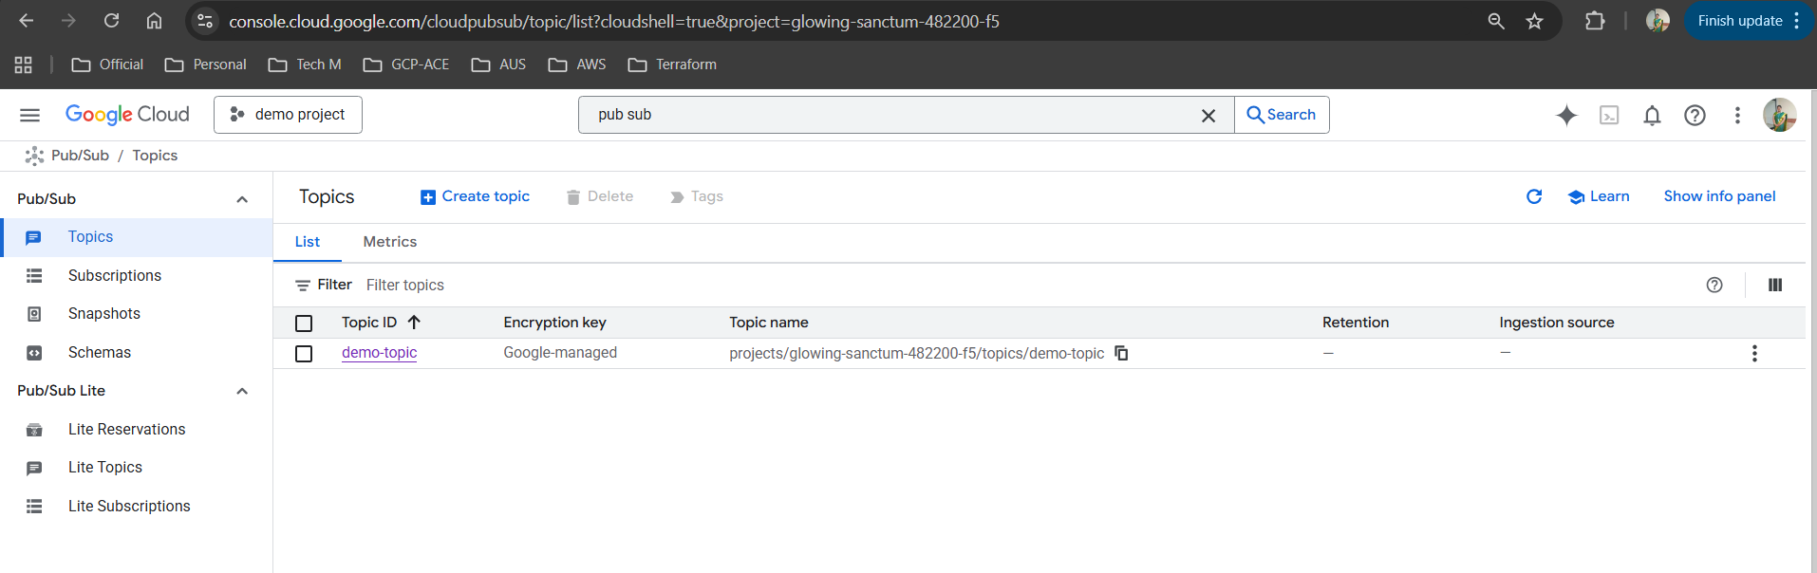
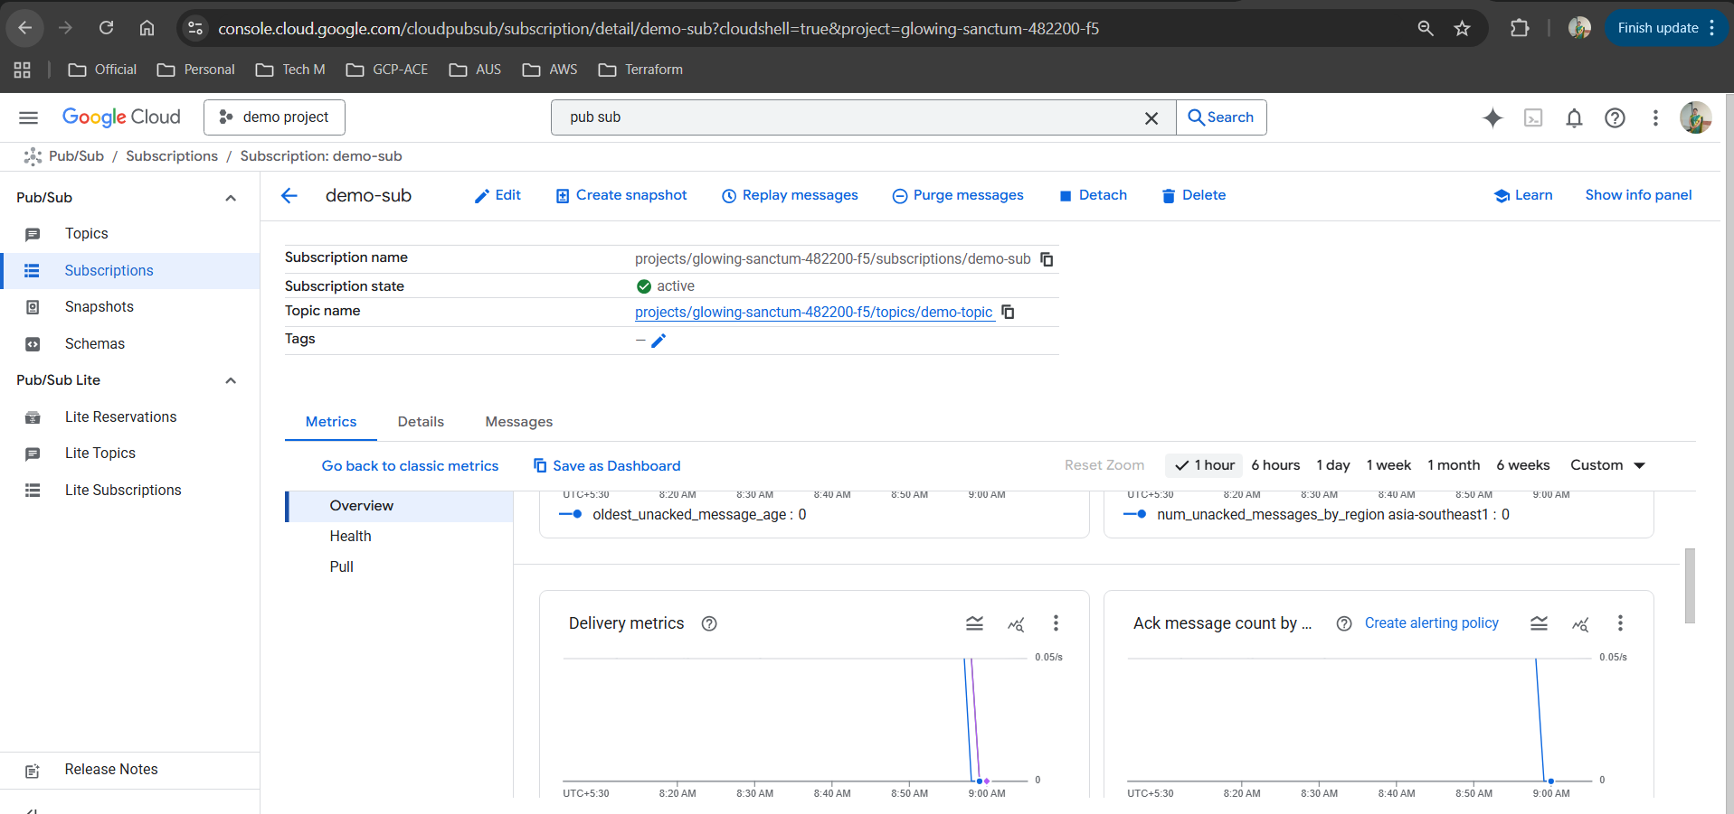

Destruction time
shylajaiyer@cloudshell:~ (glowing-sanctum-482200-f5)$ gcloud pubsub subscriptions delete demo-sub --quiet
Deleted subscription [projects/glowing-sanctum-482200-f5/subscriptions/demo-sub].
shylajaiyer@cloudshell:~ (glowing-sanctum-482200-f5)$ gcloud pubsub topics delete demo-topic --quiet
Deleted topic [projects/glowing-sanctum-482200-f5/topics/demo-topic].

